**1. Prerequisites**

visual studio 2017

.net framework 4.6.2

# **2.** **Process Diagram and Output**

**Convert Numbers to Words via web page**

**URL:-** <http://localhost:4040/Index.html>

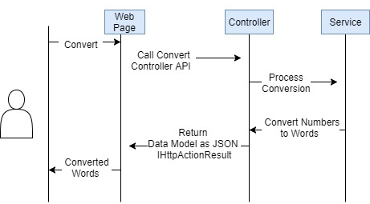

**OutPut**:-

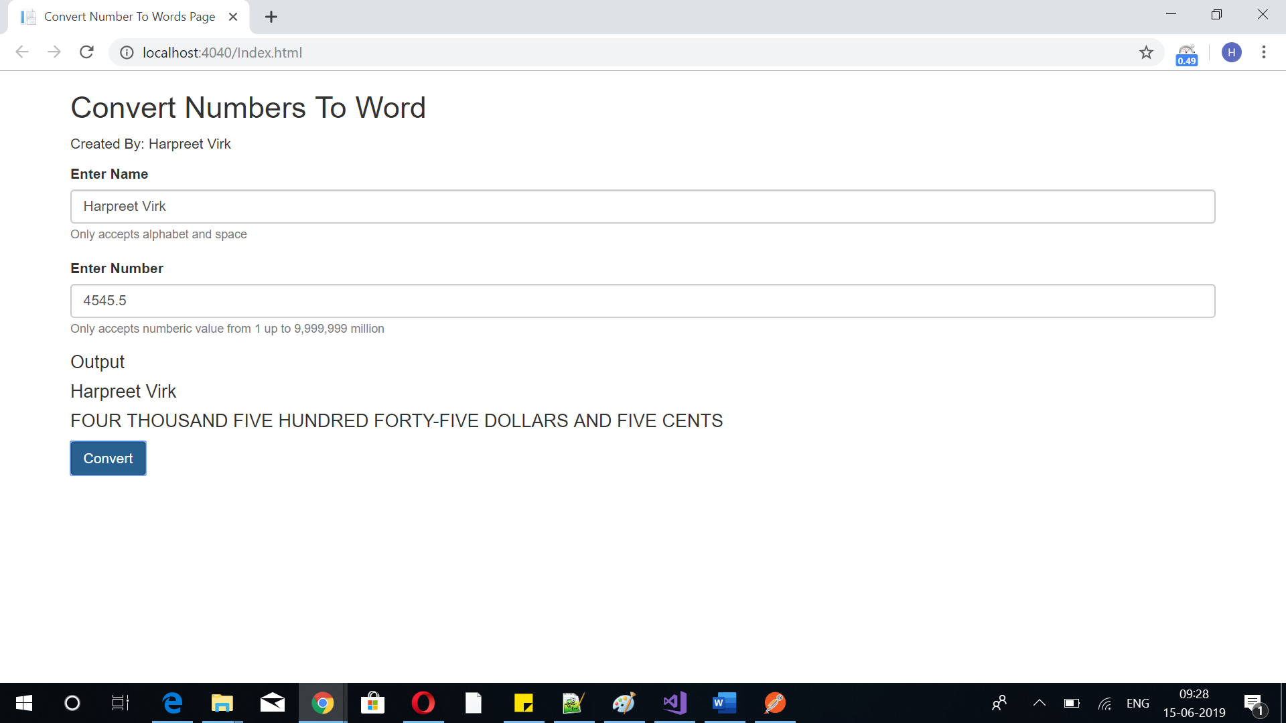

**Convert Numbers to Words via Postman**

Api Url**:-** http://localhost:4040/api/WordConverter/ConvertNumberToWords

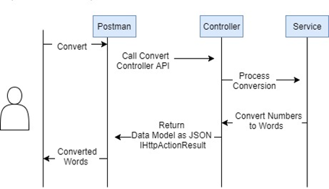

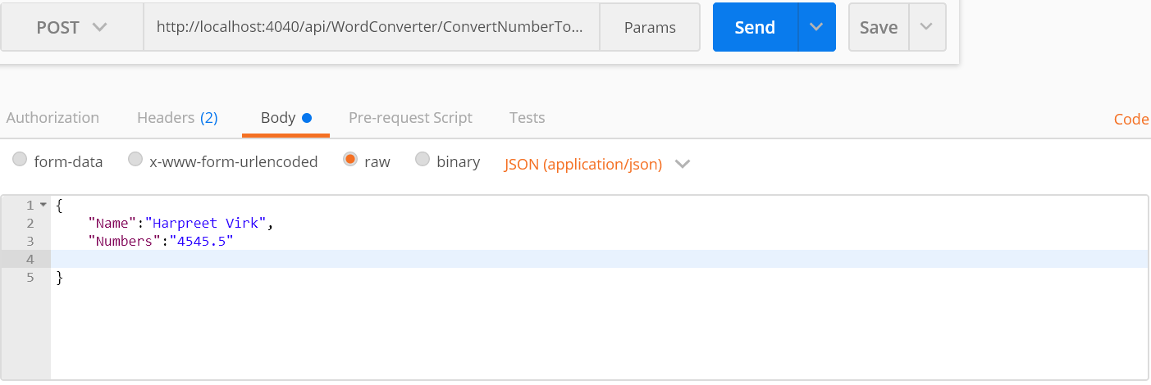

Out Put:-

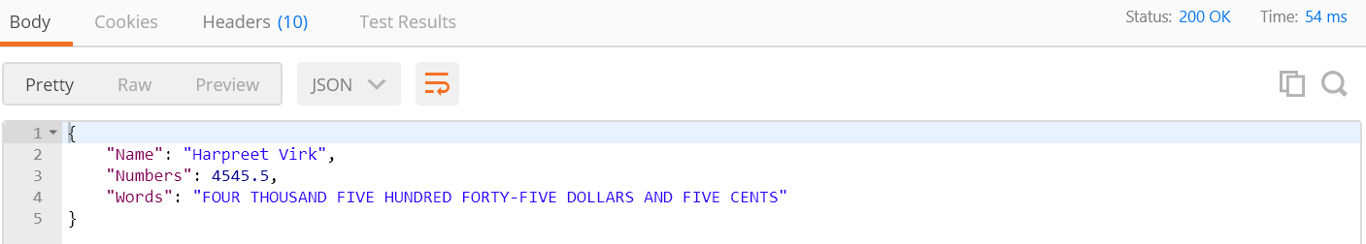

**3. Technical Implementation**

* Created a DataModel to store the user input data (name & numbers)
* Created a NumbersToWordsModel to store the place value
  1. Ones – ranges from 1-9
  2. Teens – ranges from 10 – 19
  3. Tens – increment by 10-90
  4. Hundreds, thousands, ten thousand, hundred thousand, million - ranges from 100-9999999
* Created an API Controller that will be exposed as an entry point/endpoint of conversion
  1. Validate the model against regex filters and error handling. Use the ResponseMessageService to pass the error message and return as ResponseErrorMessageModel.

Process the DataModel to Converter Service

* Created Converter Service to do the logic of conversion
  1. Add conditions to determine the digits. If matched, then convert the number range to words. Do recursive call until all numbers are converted to words. Use ‘/’ to get the whole number and % to get the remainder.
  2. Format the words and clean TEN-ONE, TEN-TWO to TEN-NINE words to teens.
  3. Format the words with ‘–‘
* Created a front-end application the displays the numbers to word in the web page
  1. Created a form with name and numbers field
  2. Created a button to help trigger the conversion
  3. Created an error handling in the html input type to prevent unexpected value
  4. Called the API via AJAX by passing the name and numbers as JSON object using Post.
  5. Displayed the converted numbers to words to the web page using Jquery

**ConvertNumberToWords API**

|  |  |
| --- | --- |
| **API Path** | /api/WordConverter/ ConvertNumberToWords |
| **Method** | Post |
| **Input** | DataModel |
| **Output** | IHttActionResult |
| **Remarks** | Convert Numbers to Words |

**DataModel**

|  |  |  |  |
| --- | --- | --- | --- |
| **Field Name** | **Type** | **Mandatory** | **Remarks** |
| Name | String | Yes | Person’s name |
| Numbers | Integer | Yes | Numbers to convert to words |
| Words | String | No | Converted string |

Input Json:

{

"Name":"Harpreet Virk",

"Numbers":"4545.5"

}

OutPut Json:-

{

"Name": "Harpreet Virk",

"Numbers": 4545.5,

"Words": "FOUR THOUSAND FIVE HUNDRED FORTY-FIVE DOLLARS AND FIVE CENTS"

}

**4. MS Test**

